Small Icosicosidodecahedron

Definition
# Source: AI Source: Provided by: [Data Path: Persons Table -> ID Column: 1, Name_En Column: Motasem Essam] -> From: [ChatGPT] on [7/25/2026]
The Small Icosicosidodecahedron is a non-convex uniform star polyhedron composed of 52 regular polygonal faces: 20 equilateral triangles, 20 regular hexagons, and 12 pentagrams.
It is characterized by its intersecting faces, pentagrammic face structure, and icosahedral symmetry.
Its classification identifiers include:
- Uniform Polyhedron Index: U₃₁
- Maeder Index: 31
- Coxeter Index: C₄₀
- Wenninger Index: W₇₁
- Har'El Index: 36
- Bowers Acronym: Siid
Its Wythoff symbol is:
$$\boxed{\frac{5}{2} 3∣3}$$

Geometric Representation
# Source: AI Source: Provided by: [Data Path: Persons Table -> ID Column: 1, Name_En Column: Motasem Essam] -> From: [ChatGPT] on [7/25/2026]
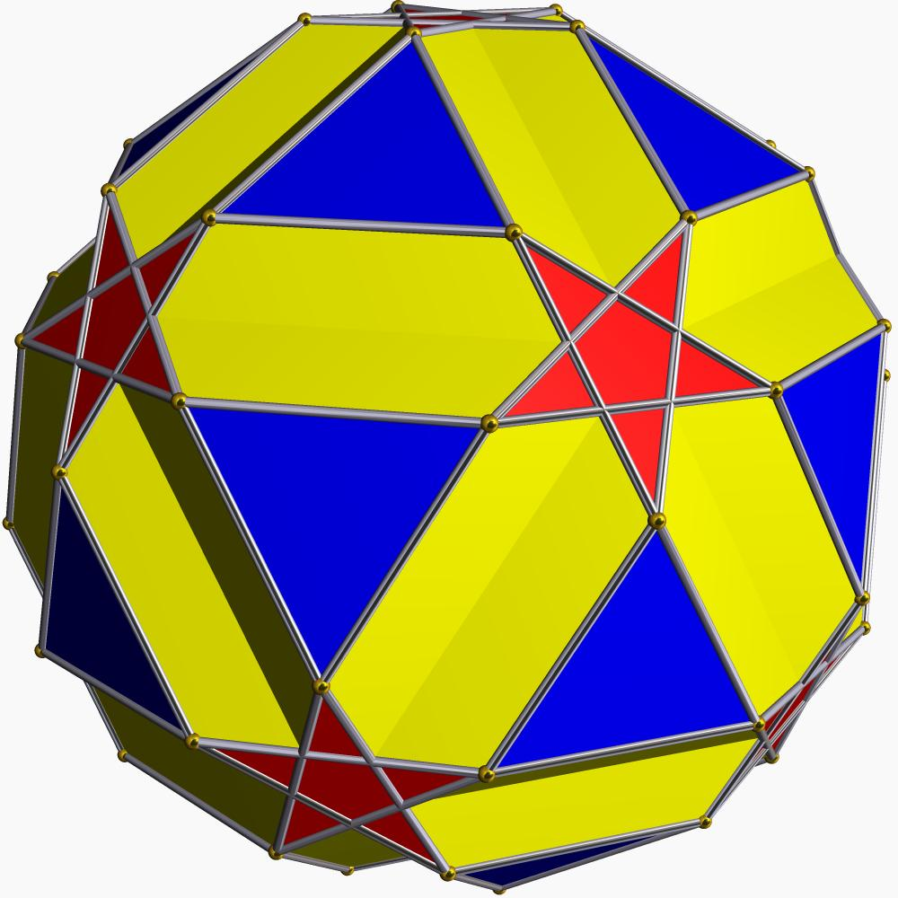

Geometric Structure
# Source: AI Source: Provided by: [Data Path: Persons Table -> ID Column: 1, Name_En Column: Motasem Essam] -> From: [ChatGPT] on [7/25/2026]
The Small Icosicosidodecahedron consists of three types of regular polygonal faces:
- Triangular faces: 20 equilateral triangles.
- Hexagonal faces: 20 regular hexagons.
- Pentagrammic faces: 12 regular pentagrams, represented by $\{5/2\}$.
Its main structural characteristics include:
- All edges have equal lengths.
- All vertices are equivalent under its symmetry group.
- Its faces intersect in three-dimensional space.
- The pentagrammic faces are self-intersecting star polygons.
- Its overall structure has icosahedral symmetry.
- Its vertex arrangement is shared with the Great Stellated Truncated Dodecahedron.

Mathematical Properties
# Source: AI Source: Provided by: [Data Path: Persons Table -> ID Column: 1, Name_En Column: Motasem Essam] -> From: [ChatGPT] on [7/25/2026]
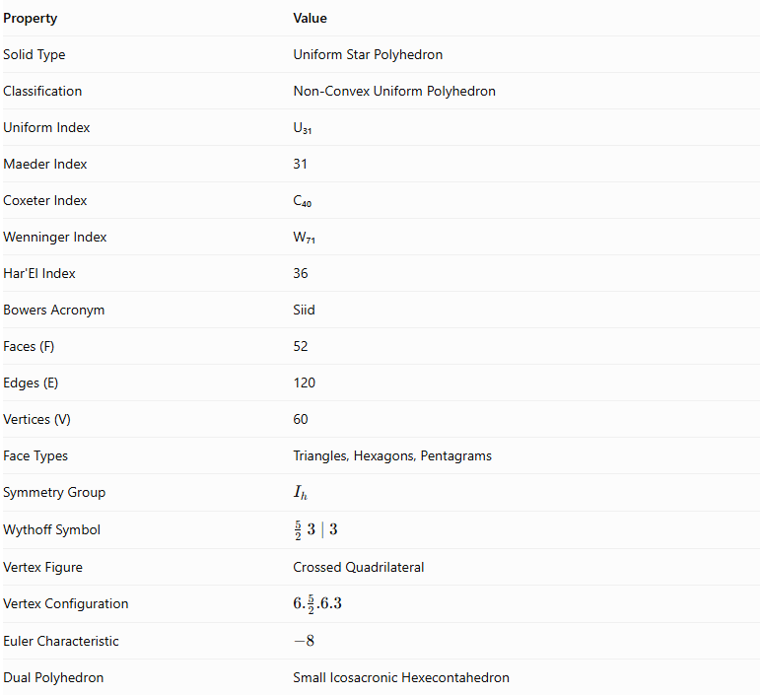
Property | Value
Solid Type | Uniform Star Polyhedron
Classification | Non-Convex Uniform Polyhedron
Uniform Index | U₃₁
Maeder Index | 31
Coxeter Index | C₄₀
Wenninger Index | W₇₁
Har'El Index | 36
Bowers Acronym | Siid
Faces (F) | 52
Edges (E) | 120
Vertices (V) | 60
Face Types | Triangles, Hexagons, Pentagrams
Symmetry Group | $$I_{h}$$
Wythoff Symbol | $$\frac{5}{2} 3∣3$$
Vertex Figure | Crossed Quadrilateral
Vertex Configuration | $$6.\frac{5}{2}.6.3$$
Euler Characteristic | $$-8$$
Dual Polyhedron | Small Icosacronic Hexecontahedron

Face Composition
# Source: AI Source: Provided by: [Data Path: Persons Table -> ID Column: 1, Name_En Column: Motasem Essam] -> From: [ChatGPT] on [7/25/2026]
The Small Icosicosidodecahedron contains 52 faces distributed among three polygon types.
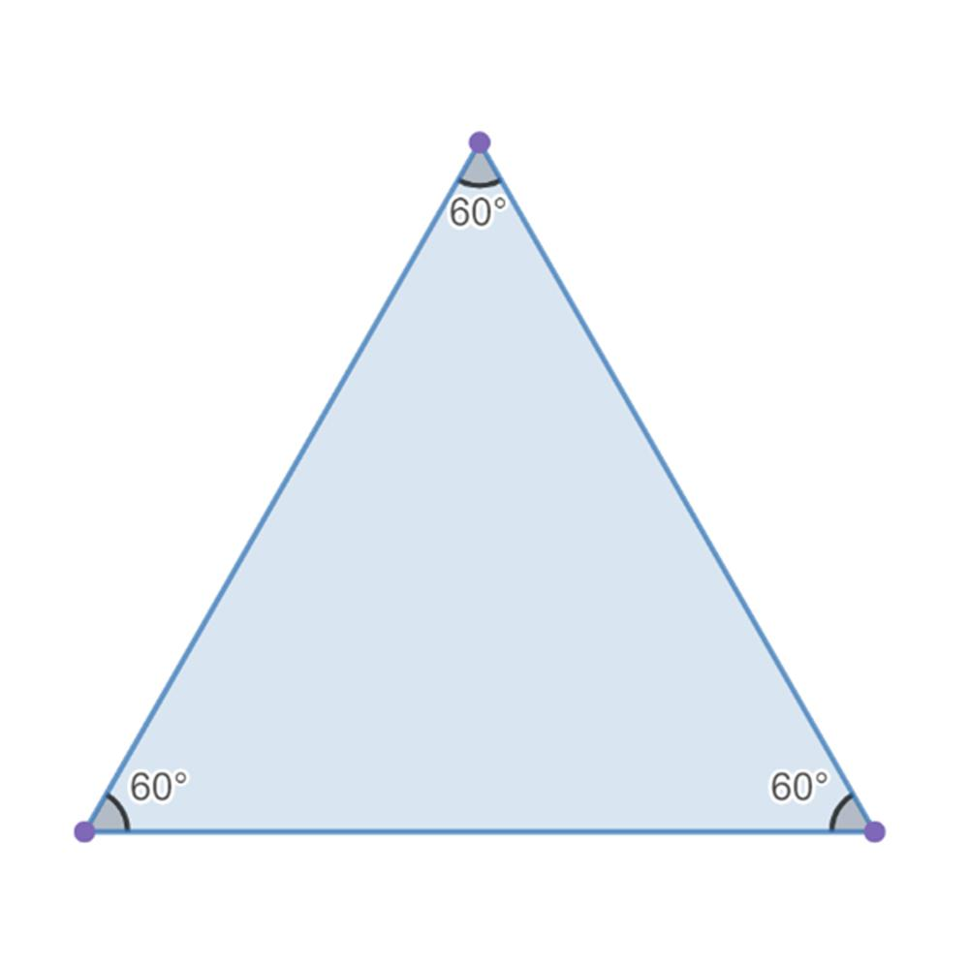
Equilateral Triangles
20
Three equal sides and three 60° angles.
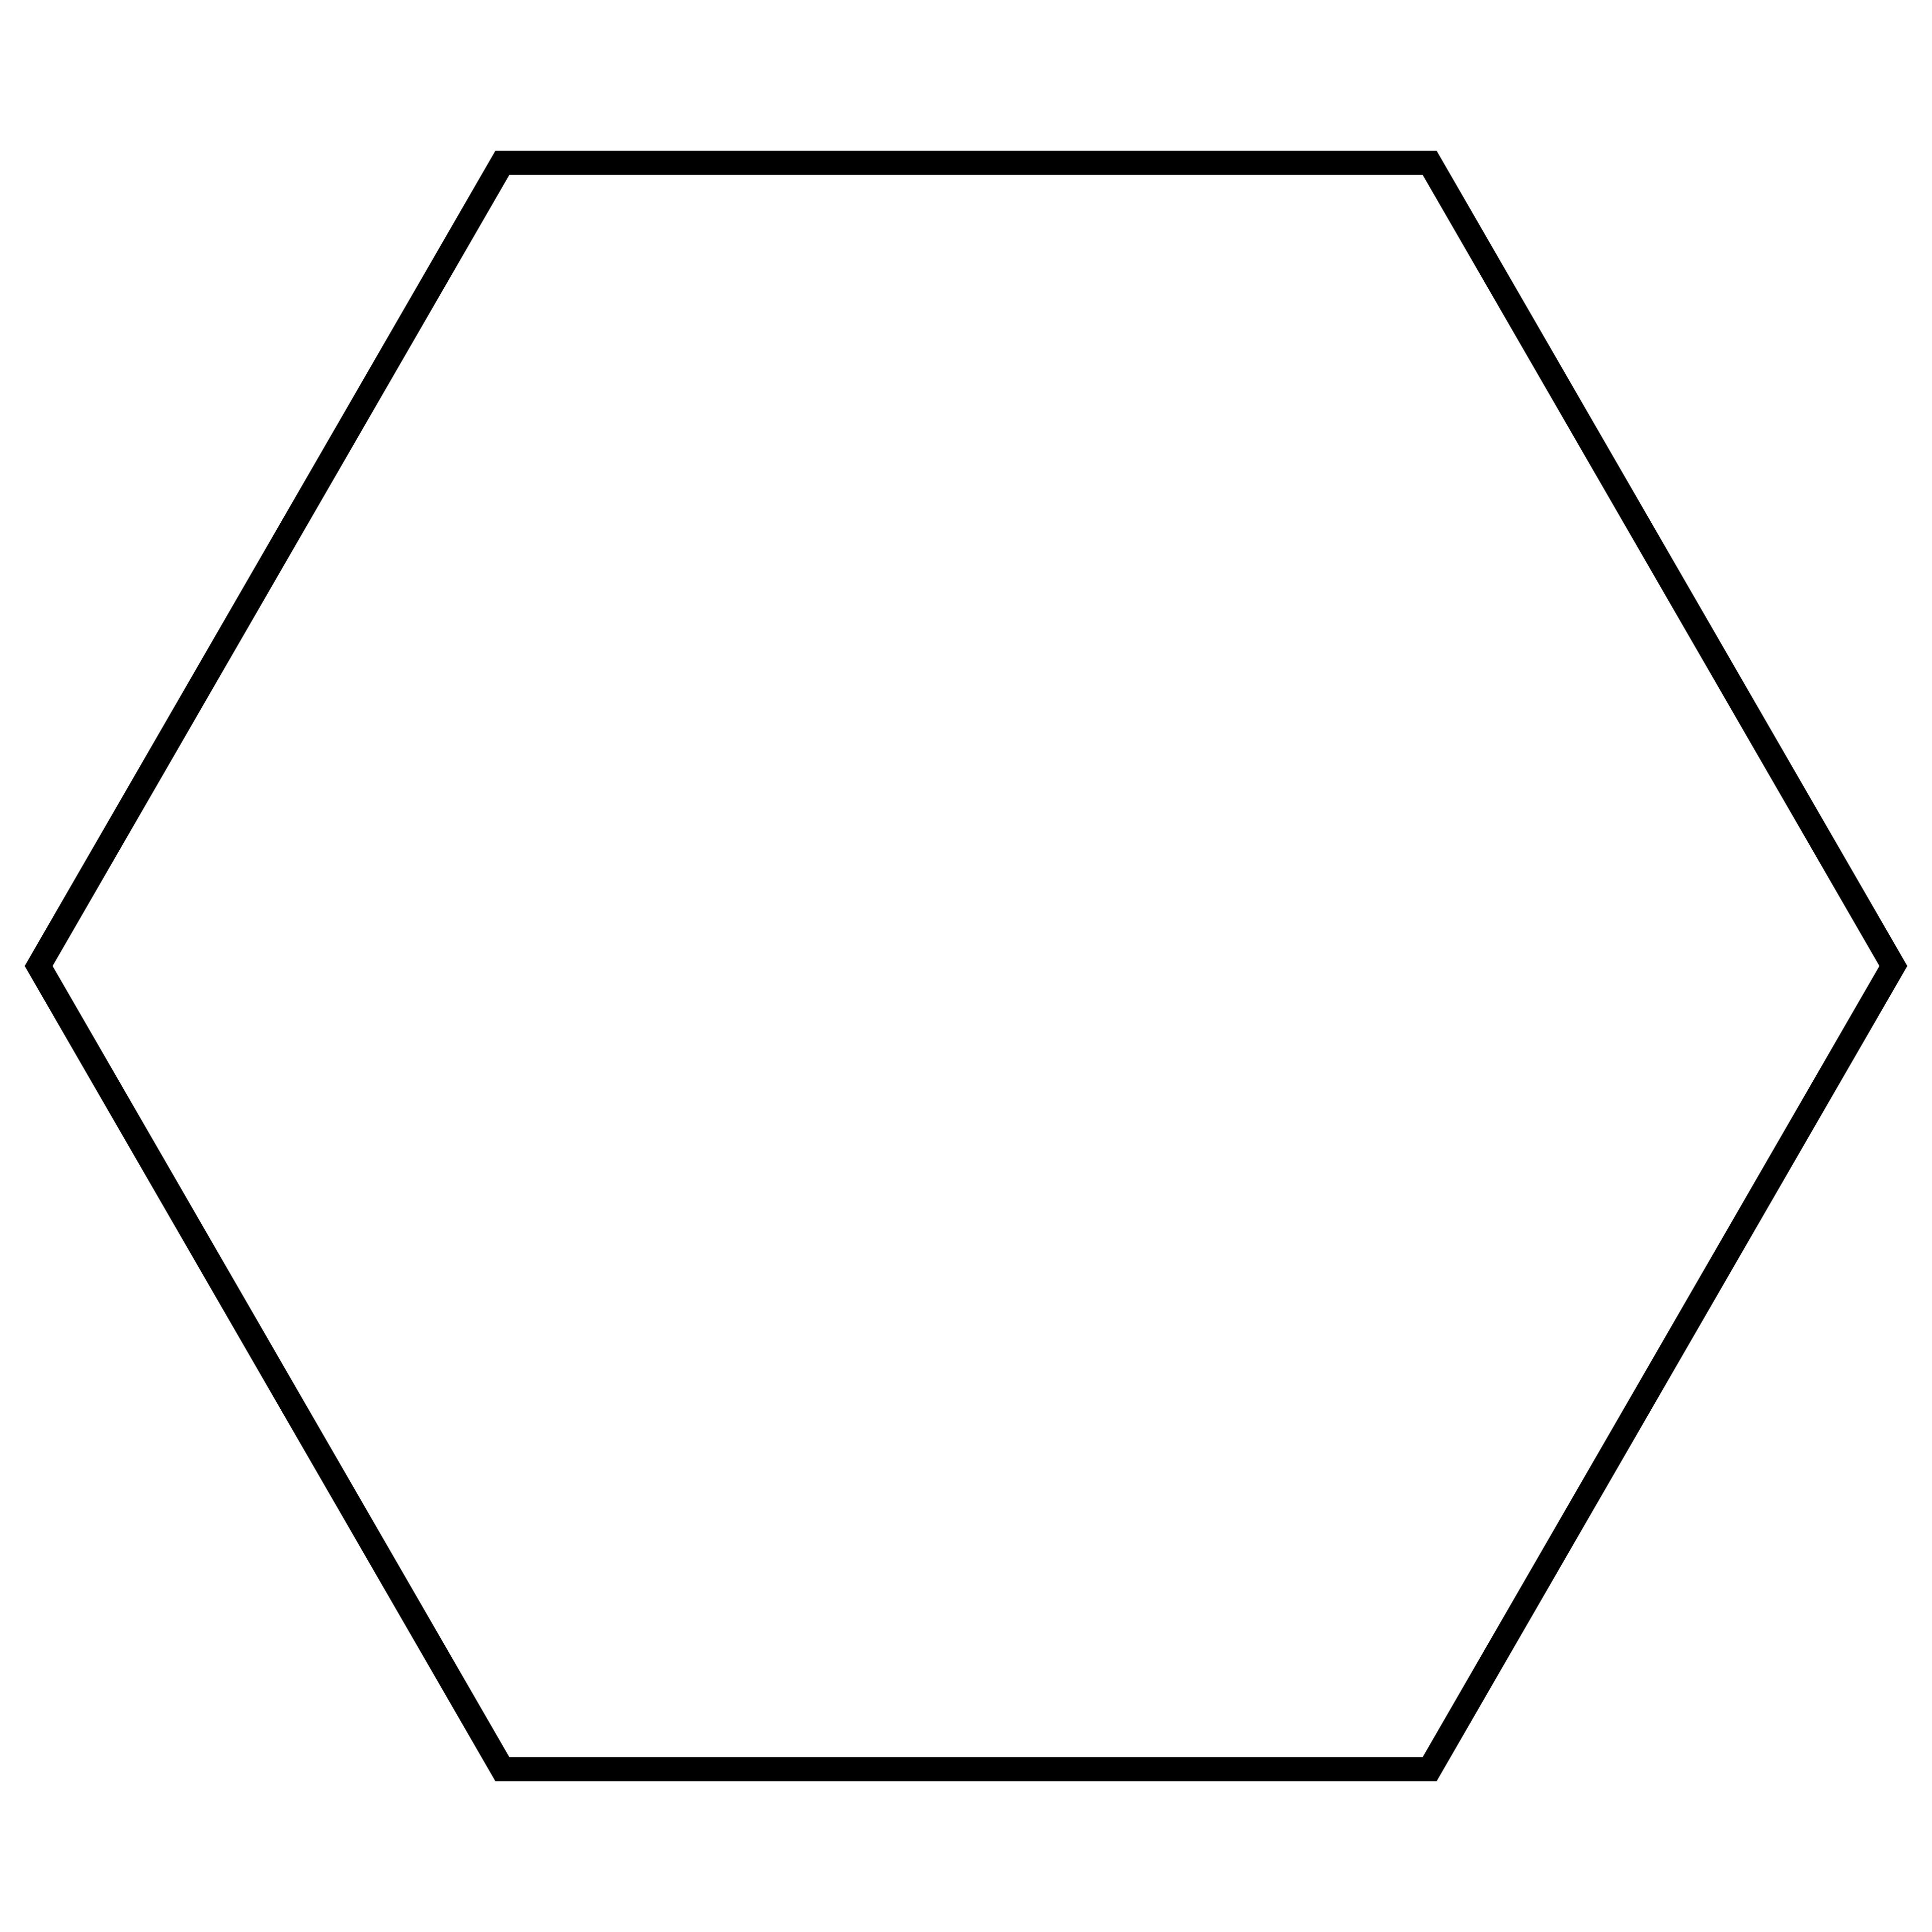
Regular Hexagons
20
Six equal sides and six 120° angles.
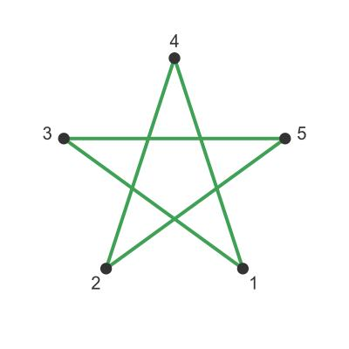
Pentagrams
12
Five vertices connected with a step of two positions.
The face composition is represented by:
$$\boxed{20\{3\}+20\{6\}+12\{\frac{5}{2}\}}$$
Where:
- $\{3\}$ represents an equilateral triangle.
- $\{6\}$ represents a regular hexagon.
- $\{5/2\}$ represents a regular pentagram.
The pentagrams are self-intersecting star polygons rather than ordinary convex pentagons.

Vertex Configuration
# Source: AI Source: Provided by: [Data Path: Persons Table -> ID Column: 1, Name_En Column: Motasem Essam] -> From: [ChatGPT] on [7/25/2026]
The Small Icosicosidodecahedron has 60 equivalent vertices.
Its vertex figure is a crossed quadrilateral, and its vertex configuration is:
$$\boxed{6.\frac{5}{2}.6.3}$$
This describes the arrangement of four face contributions around each vertex:
- A regular hexagon.
- A pentagrammic face.
- Another regular hexagon.
- An equilateral triangle.
The pentagrammic contribution creates the crossed arrangement associated with its non-convex geometry.

Construction
# Source: AI Source: Provided by: [Data Path: Persons Table -> ID Column: 1, Name_En Column: Motasem Essam] -> From: [ChatGPT] on [7/25/2026]
The Small Icosicosidodecahedron can be understood through its Wythoff construction.
Its construction can be described through these stages:
- Begin with the icosahedral symmetry arrangement.
- Establish the vertex positions using the Wythoff symbol $\frac{5}{2} 3∣3$.
- Arrange 20 equilateral triangular faces.
- Arrange 20 regular hexagonal faces.
- Introduce 12 pentagrammic faces using the $\{5/2\}$ star-polygon arrangement.
- Connect the faces according to the uniform vertex configuration.
- Allow the resulting polygonal faces to intersect in three-dimensional space.
The resulting polyhedron contains 52 faces, 120 edges, and 60 vertices.

Geometric Dimensions and Formulas
# Source: AI Source: Provided by: [Data Path: Persons Table -> ID Column: 1, Name_En Column: Motasem Essam] -> From: [ChatGPT] on [7/25/2026]
Let:
- $a$ = common edge length.
- $A_{3}$ = area of one equilateral triangular face.
- $A_{6}$ = area of one regular hexagonal face.
- $A_{5}^{*}$ = signed area of one pentagrammic face.
- $S$ = sum of the individual face areas.
Equilateral triangular face area:
$$A_{3}=\frac{\sqrt{3}}{4}a^{2}$$
Regular hexagonal face area:
$$A_{6}=\frac{3\sqrt{3}}{2}a^{2}$$
Pentagrammic face area:
For a regular pentagram with edge length $a$, the signed polygon area is:
$$A_{5}^{*}=\frac{5a^{2}}{4sin{72}^{∘}}$$
This is the algebraic area of the self-intersecting pentagram, not the sum of its five triangular regions.
Sum of individual face areas using signed pentagram areas:
$$S=20A_{3}+20A_{6}+12A_{5}^{*}$$
Substituting:
$$S=20(\frac{\sqrt{3}}{4}a^{2})+20(\frac{3\sqrt{3}}{2}a^{2})+12(\frac{5a^{2}}{4sin{72}^{∘}})$$
Therefore:
$$\boxed{S=(35\sqrt{3}+\frac{15}{sin{72}^{∘}})a^{2}}$$
This is a mathematical sum of individual face areas under the stated signed-area convention, not the exposed external boundary area.
A volume formula requires an explicit convention for interpreting the self-intersecting solid and its winding density.

Euler Characteristic
# Source: AI Source: Provided by: [Data Path: Persons Table -> ID Column: 1, Name_En Column: Motasem Essam] -> From: [ChatGPT] on [7/25/2026]
Using the conventional numbers of vertices, edges, and faces:
$$χ=V-E+F$$
Substituting:
$$χ=60-120+52$$
$$\boxed{χ=-8}$$
For a connected, closed, orientable surface:
$$χ=2-2g$$
Therefore:
$$-8=2-2g$$
$$\boxed{g=5}$$
The corresponding abstract surface has genus 5. This is a topological interpretation of its combinatorial structure, not a description of a convex solid.

Symmetry
# Source: AI Source: Provided by: [Data Path: Persons Table -> ID Column: 1, Name_En Column: Motasem Essam] -> From: [ChatGPT] on [7/25/2026]
The Small Icosicosidodecahedron has full icosahedral symmetry.
Its symmetry group is:
$$\boxed{I_{h}}$$
Its symmetry includes:
- Rotational symmetry associated with the icosahedron and dodecahedron.
- Reflection symmetry.
- Inversion symmetry.
- Equivalent vertices under its symmetry transformations.
This symmetry ensures that all vertices have the same local face arrangement.

Constructing a Small Icosicosidodecahedron

Geometric Instruments
# Source: AI Source: Provided by: [Data Path: Persons Table -> ID Column: 1, Name_En Column: Motasem Essam] -> From: [ChatGPT] on [7/25/2026]
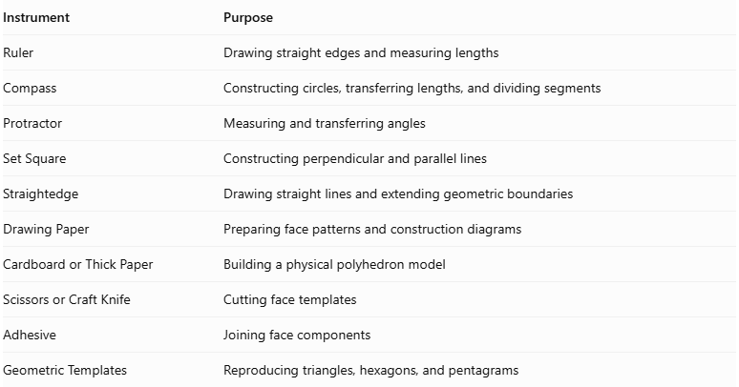
Instrument | Purpose
Ruler | Drawing straight edges and measuring lengths
Compass | Constructing circles, transferring lengths, and dividing segments
Protractor | Measuring and transferring angles
Set Square | Constructing perpendicular and parallel lines
Straightedge | Drawing straight lines and extending geometric boundaries
Drawing Paper | Preparing face patterns and construction diagrams
Cardboard or Thick Paper | Building a physical polyhedron model
Scissors or Craft Knife | Cutting face templates
Adhesive | Joining face components
Geometric Templates | Reproducing triangles, hexagons, and pentagrams

Instrument-Based Construction Procedures

Method 1: Construction Using Icosahedral Symmetry and Geometric Reflection
# Source: AI Source: Provided by: [Data Path: Persons Table -> ID Column: 1, Name_En Column: Motasem Essam] -> From: [ChatGPT] on [7/25/2026]
This method uses the fivefold, threefold, and twofold symmetry directions of an icosahedral arrangement to establish the uniform polyhedron's geometric framework.
The Wythoff construction associated with the symbol $\frac{5}{2} 3∣3$ provides the underlying symmetry-based arrangement.
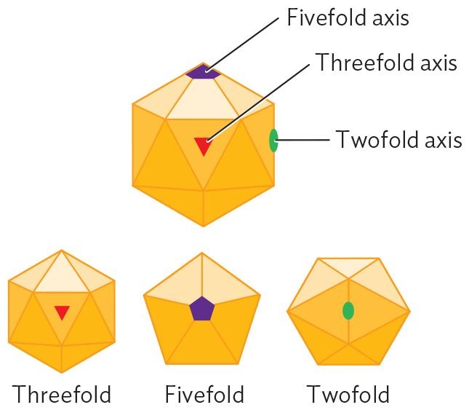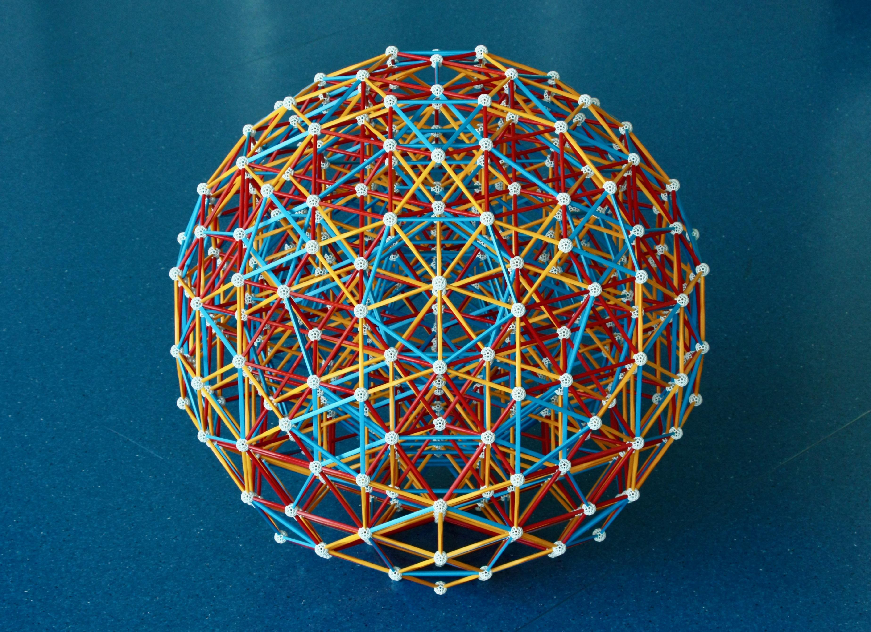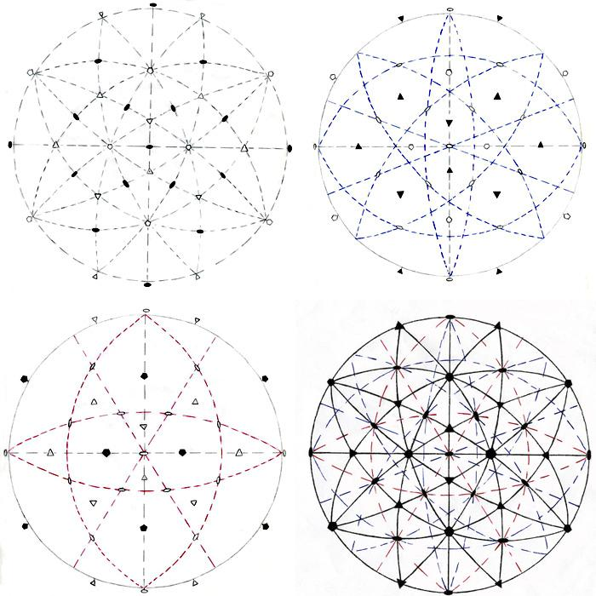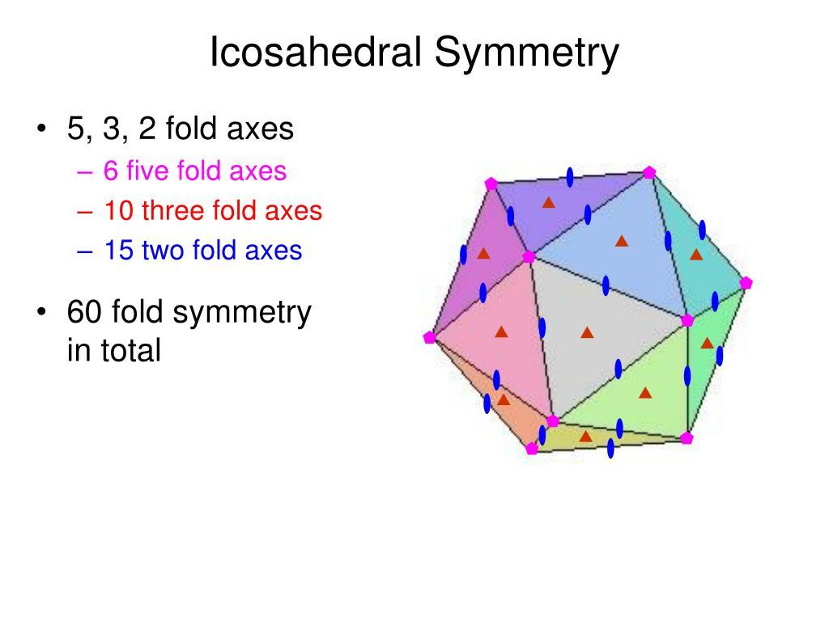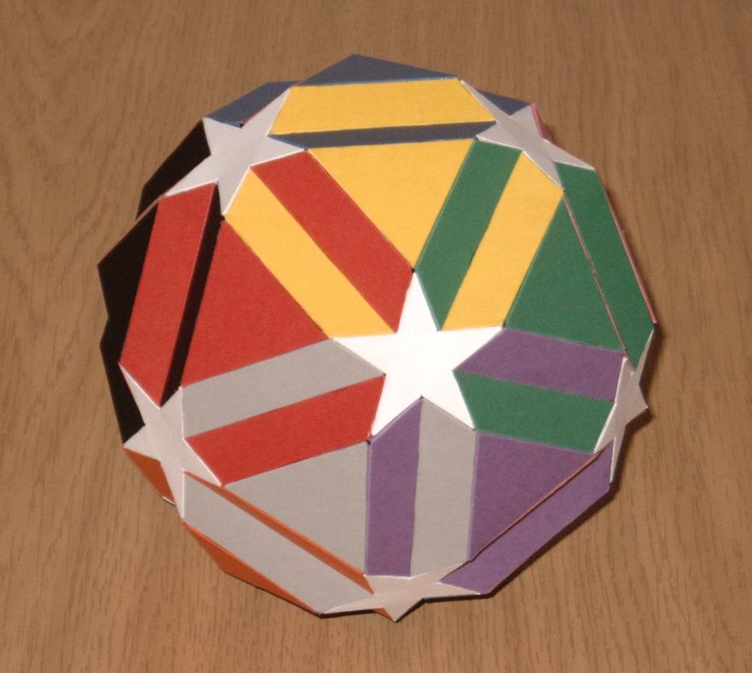
Step 1: Construct the Icosahedral Symmetry Framework
- Draw a regular pentagon using a compass and ruler.
- Construct its fivefold symmetry arrangement.
- Establish the associated triangular and pentagonal geometric directions.
- Use repeated geometric divisions and reflected arrangements to establish the icosahedral symmetry framework.
Step 2: Construct the Symmetry Reference Lines
- Identify the fivefold, threefold, and twofold symmetry directions.
- Draw the corresponding reference axes.
- Use a compass and protractor to transfer the required angular relationships.
- Maintain consistent symmetry between repeated sections.
Step 3: Establish the Uniform Vertex Arrangement
- Use the symmetry framework to locate the 60 vertices.
- Arrange the vertices in equivalent groups under the icosahedral symmetry.
- Transfer equal distances using the compass.
- Verify that the framework supports the required 120-edge arrangement.
Step 4: Construct the Triangular Faces
- Identify the groups of three vertices forming equilateral triangles.
- Connect their vertices with a ruler.
- Repeat the construction through the symmetry-related positions.
- Complete all 20 triangular faces.
Step 5: Construct the Hexagonal Faces
- Identify the groups of six vertices forming regular hexagons.
- Connect the six vertices in cyclic order.
- Check that all six sides have equal lengths.
- Complete all 20 hexagonal faces.
Step 6: Construct the Pentagrammic Faces
- Identify the 12 five-vertex groups.
- Arrange the five vertices in a regular pentagonal order.
- Connect each vertex to the second vertex ahead in the cyclic sequence.
- This creates a regular pentagram with the symbol $\{5/2\}$.
Step 7: Complete the Polyhedron
- Connect the face boundaries according to the established vertex arrangement.
- Preserve the star-polygon intersections.
- Verify that 20 triangles, 20 hexagons, and 12 pentagrams are present.
- Inspect the model from multiple viewing directions.
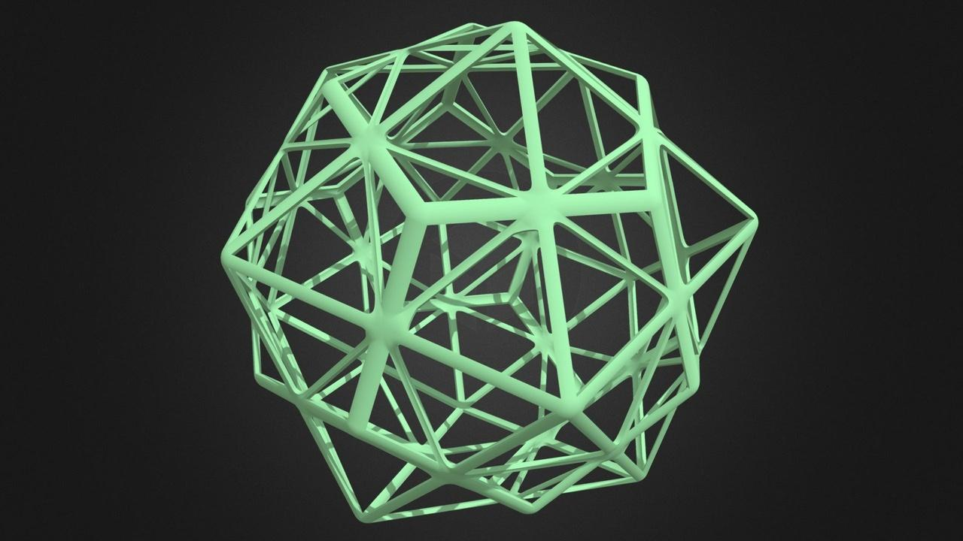

Method 2: Construction Using Polygonal Face Templates
# Source: AI Source: Provided by: [Data Path: Persons Table -> ID Column: 1, Name_En Column: Motasem Essam] -> From: [ChatGPT] on [7/25/2026]
This method is suitable for producing a physical paper or cardboard model. It requires accurate face templates and careful positioning because the solid is non-convex and its pentagrammic faces intersect.
Step 1: Prepare the Triangular Face Templates
- Construct an equilateral triangle with side length $a$.
- Verify that all three sides are equal.
- Prepare 20 copies.
Step 2: Prepare the Hexagonal Face Templates
- Construct a regular hexagon with side length $a$.
- Use a compass to transfer the same side length around the circumference.
- Verify that all six sides are equal.
- Prepare 20 copies.
Step 3: Prepare the Pentagrammic Face Templates
- Construct a regular pentagon with side length $a$.
- Label its five vertices in cyclic order.
- Connect every vertex to the second vertex ahead.
- Trace the resulting pentagram.
- Prepare 12 copies.
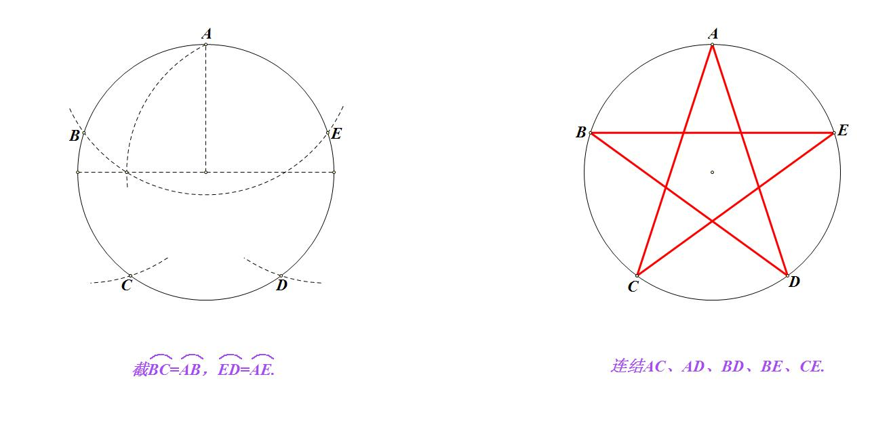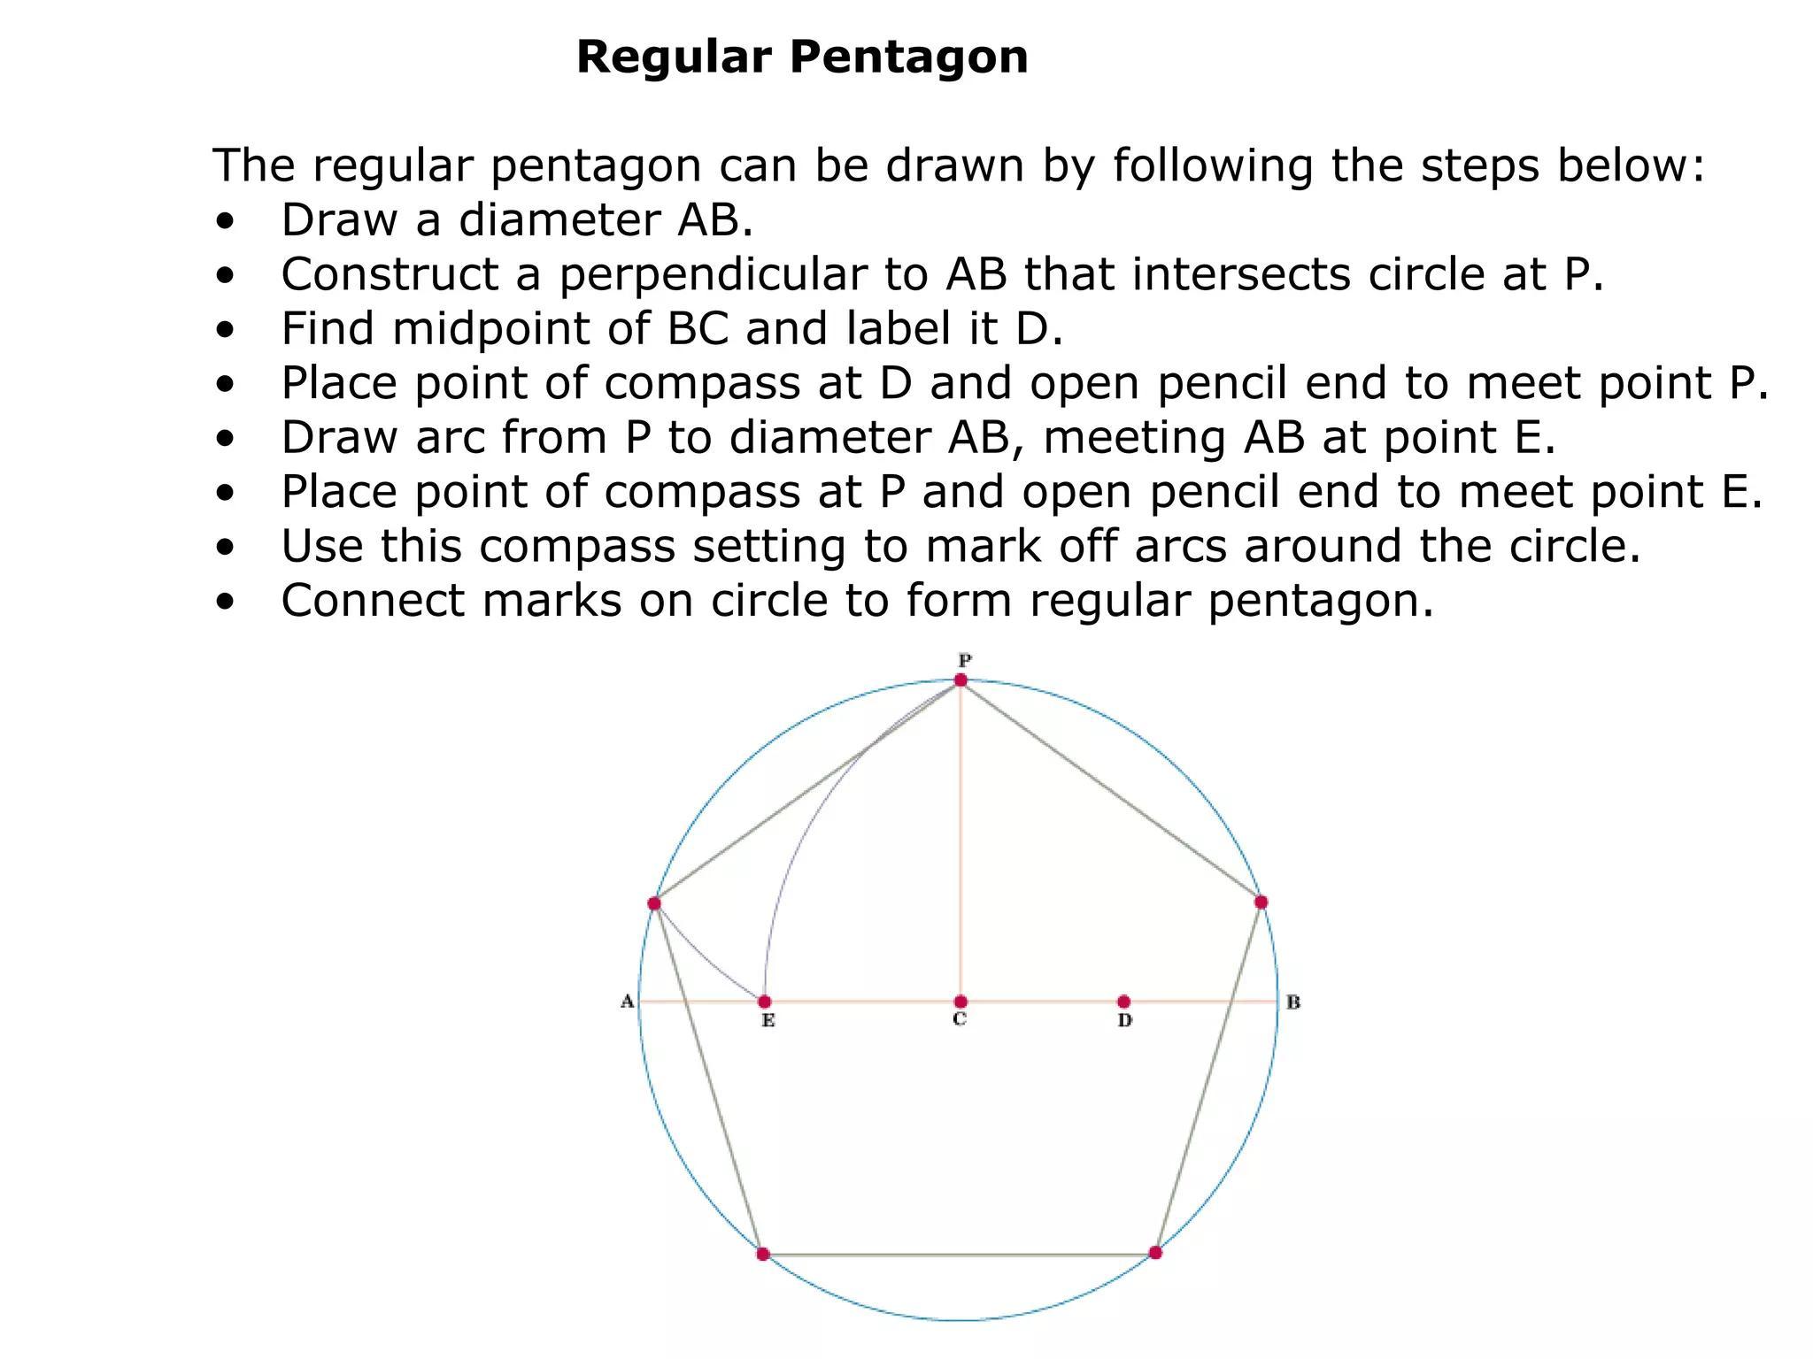
Step 4: Establish the Common Edge Length
- Use the same edge length $a$ for all three face types.
- Check the edge lengths with a compass.
- Ensure that all face templates use consistent measurements.
Step 5: Arrange the Face Templates
- Position the triangular, hexagonal, and pentagrammic faces according to the vertex configuration.
- Use the icosahedral symmetry framework to determine their orientations.
- Ensure that the pentagrams are connected according to their star-polygon edges.
Step 6: Assemble the Model
- Cut out the templates.
- Join corresponding edges using tabs or suitable connectors.
- Preserve the intersecting regions of the pentagrammic faces.
- Check the completed solid from multiple directions.

Method 3: Construction Using a Geometric Wireframe
# Source: AI Source: Provided by: [Data Path: Persons Table -> ID Column: 1, Name_En Column: Motasem Essam] -> From: [ChatGPT] on [7/25/2026]
This method focuses on constructing the 120-edge framework before adding or marking the polygonal face regions.
Step 1: Establish the Vertex Positions
- Prepare an icosahedrally symmetric geometric reference framework.
- Mark the 60 required vertex positions.
- Transfer equal lengths using a compass.
Step 2: Construct the Edge Network
- Connect the vertices according to the small icosicosidodecahedron's edge arrangement.
- Use a ruler to draw the 120 edges.
- Check that all edges have equal lengths.
Step 3: Identify the Face Boundaries
- Mark the 20 triangular face boundaries.
- Mark the 20 hexagonal face boundaries.
- Mark the 12 pentagrammic face boundaries.
Step 4: Complete the Star Geometry
- Draw the pentagrammic connections.
- Distinguish their crossing points from the actual polyhedron vertices.
- Preserve the correct edge intersections.
Step 5: Verify the Framework
- Count all 60 vertices.
- Count all 120 edges.
- Confirm the 52 face regions.
- Check the icosahedral symmetry.

Relationship to Other Geometric Solids
# Source: AI Source: Provided by: [Data Path: Persons Table -> ID Column: 1, Name_En Column: Motasem Essam] -> From: [ChatGPT] on [7/25/2026]
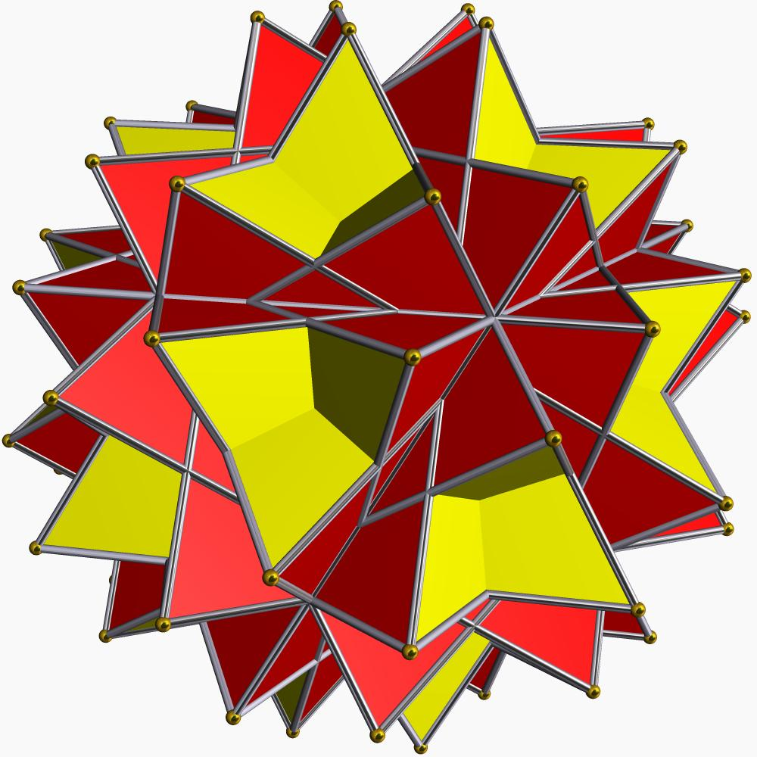
Great Stellated Truncated Dodecahedron
Shares its vertex arrangement with the Small Icosicosidodecahedron.
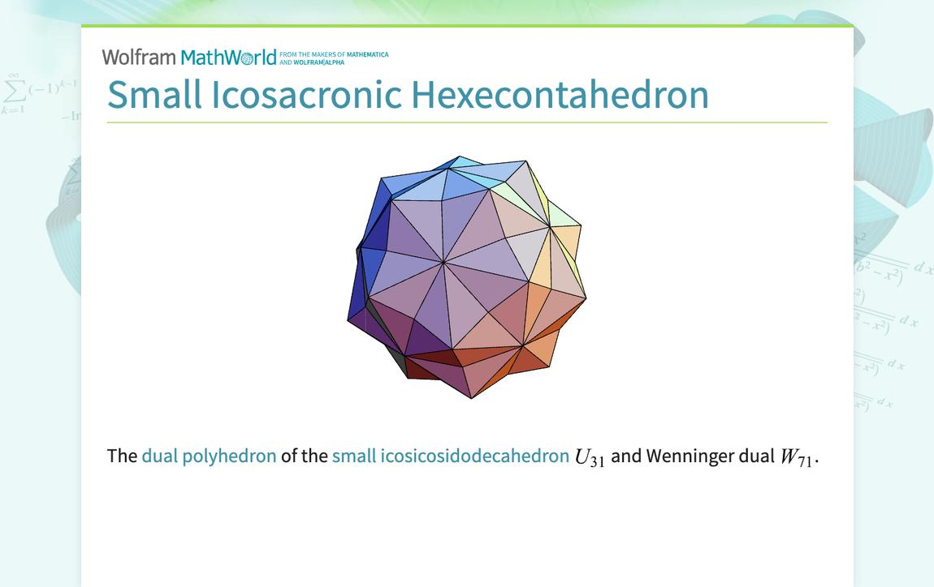
Small Icosacronic Hexecontahedron
The dual polyhedron, with 60 faces corresponding to the 60 vertices of the Small Icosicosidodecahedron.
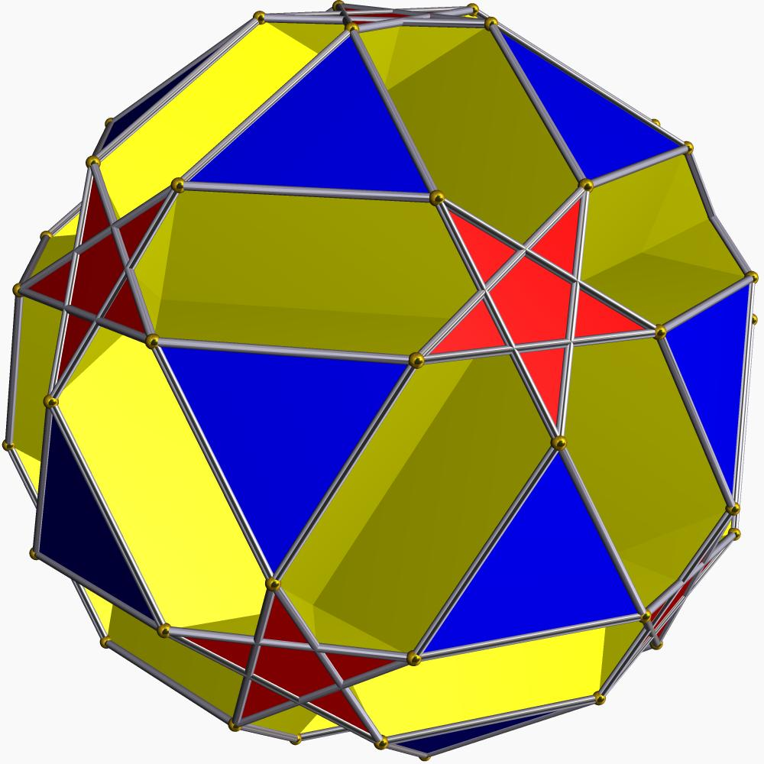
Small Ditrigonal Dodecicosidodecahedron
Shares the triangular and pentagrammic faces and their associated edges.
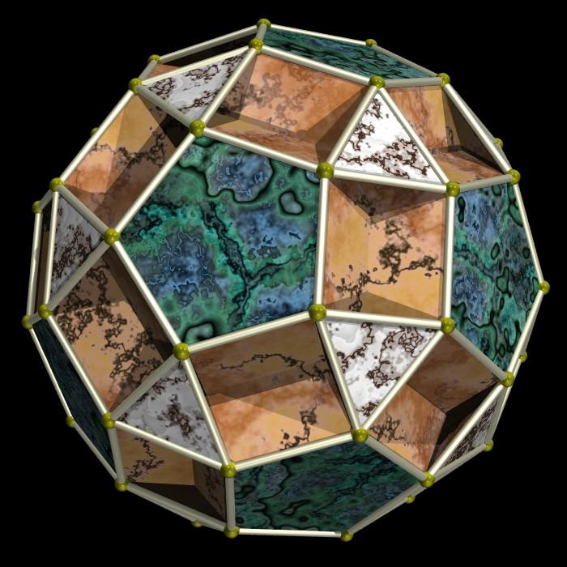
Small Dodecicosahedron
Shares the hexagonal face arrangement with the Small Icosicosidodecahedron.

Comparison with Related Uniform Star Polyhedra
# Source: AI Source: Provided by: [Data Path: Persons Table -> ID Column: 1, Name_En Column: Motasem Essam] -> From: [ChatGPT] on [7/25/2026]
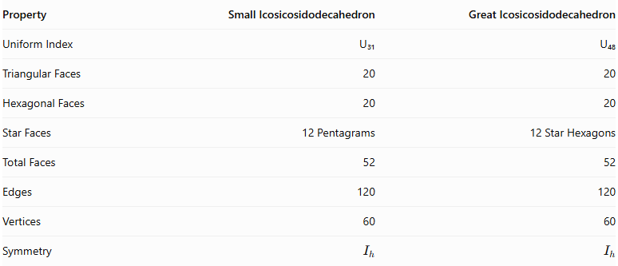
Property | Small Icosicosidodecahedron | Great Icosicosidodecahedron
Uniform Index | U₃₁ | U₄₈
Triangular Faces | 20 | 20
Hexagonal Faces | 20 | 20
Star Faces | 12 Pentagrams | 12 Star Hexagons
Total Faces | 52 | 52
Edges | 120 | 120
Vertices | 60 | 60
Symmetry | $$I_{h}$$ | $$I_{h}$$
The main difference is the star-polygon arrangement and the corresponding vertex configuration.

Main Classification
# Source: AI Source: Provided by: [Data Path: Persons Table -> ID Column: 1, Name_En Column: Motasem Essam] -> From: [ChatGPT] on [7/25/2026]
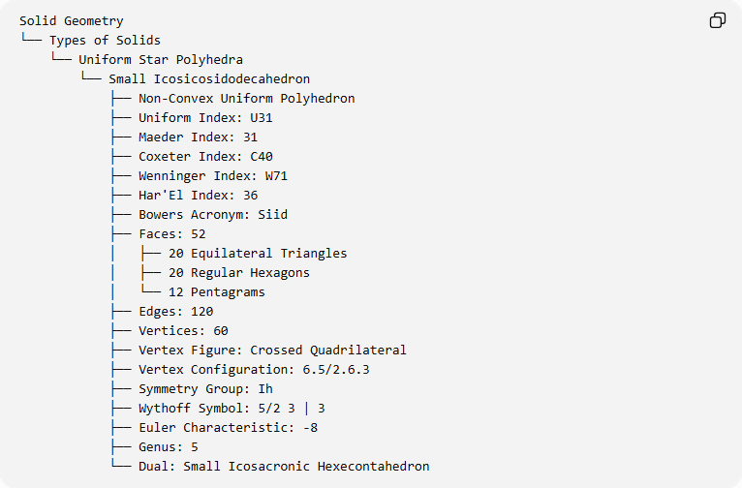
Solid Geometry
└── Types of Solids
└── Uniform Star Polyhedra
└── Small Icosicosidodecahedron
├── Non-Convex Uniform Polyhedron
├── Uniform Index: U31
├── Maeder Index: 31
├── Coxeter Index: C40
├── Wenninger Index: W71
├── Har'El Index: 36
├── Bowers Acronym: Siid
├── Faces: 52
│ ├── 20 Equilateral Triangles
│ ├── 20 Regular Hexagons
│ └── 12 Pentagrams
├── Edges: 120
├── Vertices: 60
├── Vertex Figure: Crossed Quadrilateral
├── Vertex Configuration: 6.5/2.6.3
├── Symmetry Group: Ih
├── Wythoff Symbol: 5/2 3 | 3
├── Euler Characteristic: -8
├── Genus: 5
└── Dual: Small Icosacronic Hexecontahedron

Key Points
# Source: AI Source: Provided by: [Data Path: Persons Table -> ID Column: 1, Name_En Column: Motasem Essam] -> From: [ChatGPT] on [7/25/2026]
- The Small Icosicosidodecahedron is a non-convex uniform star polyhedron.
- It is classified as U₃₁.
- It contains 52 faces: 20 triangles, 20 hexagons, and 12 pentagrams.
- It has 120 edges and 60 vertices.
- Its pentagrammic faces are represented by $\{5/2\}$.
- Its vertex configuration is $6.5/2.6.3$.
- Its symmetry group is $I_{h}$.
- Its Euler characteristic is $-8$.
- Its dual is the Small Icosacronic Hexecontahedron.
- It shares its vertex arrangement with the Great Stellated Truncated Dodecahedron.

Conclusion
# Source: AI Source: Provided by: [Data Path: Persons Table -> ID Column: 1, Name_En Column: Motasem Essam] -> From: [ChatGPT] on [7/25/2026]
The Small Icosicosidodecahedron is a complex uniform star polyhedron distinguished by its combination of equilateral triangles, regular hexagons, and pentagrammic faces. Its 60 vertices, 120 edges, and icosahedral symmetry create a highly structured non-convex geometry. Its dual relationship and shared arrangements with other uniform star polyhedra make it an important member of the uniform polyhedra family.

